**LAKSHMIPAT SINGHANIA ACADEMY**

**2020-21**

TOPIC: MOUSE

Assignment No.: 3  
Last date of submission: 17.07.2020

|  |  |  |  |  |
| --- | --- | --- | --- | --- |
| left button | scroll wheel | cable wire | body | right button |

I. Label the computer mouse given below using words from the help box:

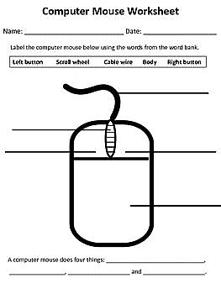

II. Can you work on the computer without the mouse? What will you use in its place?